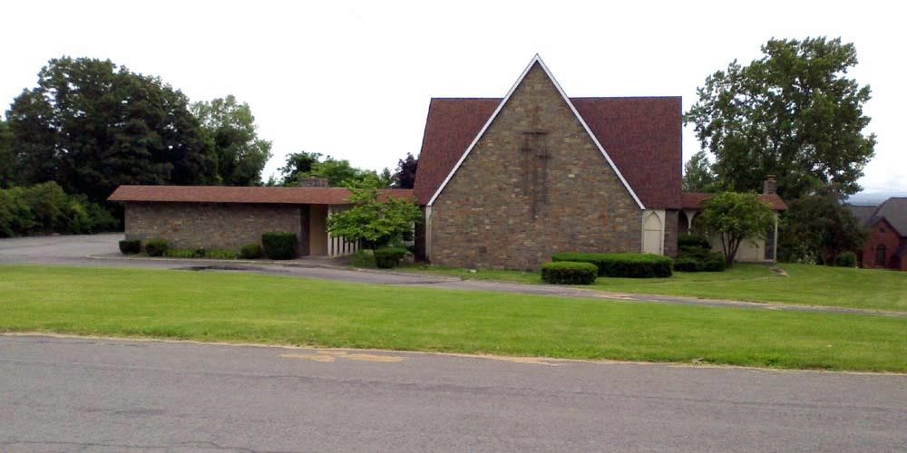
The Messenger
Grace United Methodist Church
16 Hillcrest Drive
Ravena, NY 12143
(518) 756-6688

Email: graceumcravena@statetel.com
Website: www.gumcravena.com
Rev. Kim Krause, Pastor

Working together to put our faith and love into practice.

Services are held at 9:30am - Parking Lot Grace FM-89.7, Temporary Sanctuary, & Facebook

JUNE 2026
FROM THE DESK OF THE PASTOR

Dear Family and Friends of Grace UMC,

This is not the letter I wanted to write – the one saying goodbye as I head to another church on July 1st, while Grace UMC will be closing its doors as of June 30th. But it is the letter that I must write. These past 9 years have been filled with joys and sorrow, ups and downs. It’s difficult for a congregation to shift from a full-time pastor to half-time. The dance of figuring out how to fill the gaps as new leaders emerged was not always graceful. But we learned new steps and new ways of being the Church. We pivoted when Covid hit and then pivoted again when we were able to worship in person, while also finding ways to include those not able to attend in-person. We continued to be the church – reaching out to our community, working to find ways to assist those in need, offering ourselves in service to others.

With the realization that the original Grace congregation (circa 1962) never wanted to be far from the people in the community, we sought a way to return to the heart of the community for worship and service. Unfortunately, structural challenges, including the failing of our roof, and a host of roadblocks prevented us from selling the building, and ultimately, informed our decision to close. Our board made this prayerfully heart-wrenching decision, which was affirmed by a church conference.

However, as we remember and claim that we are a resurrection people, we know that this closing is not the end to the work of Grace. The people of Grace will continue, as God works in them and through them, in new ways. Grace in Action will be starting in July, without being tethered to the UMC, and will be free to make decisions that will be a blessing for the community. More information will be available later this month. In the meantime, please be in prayer for the congregation as it transitions.

I will be with you through the end of the month. I intend to be in worship with you and to walk alongside you as you walk through this time of grief and sorrow, as you also anticipate the next thing that God will do in and through you. I am excited by the new possibilities that you see and are moving into and I look forward to hearing about your adventures in ministry as you continue to be a people of grace, love, and hope.

And – may you continue to work together, to put your faith and love into action and practice.

Peace for the Journey,
Pastor Kim

If you know where you would like to move your membership, please let Pastor Kim or Fran Lobdell know. Once the church is closed, the membership book will be sent to Delmar First UMC. This does not mean that you must go there. It simply means that if you want your membership at a United Methodist Church, you will need to get a transfer letter from them.
Worship will continue until the end of June. On June 28th, the worship service will include deconsecrating the sanctuary and a final service of closing. All are welcome to attend.





5 Pam Ginder
20 Kristina Mantynen Gish

JUNE 2026 SPECIAL DAYS
- Flag Day — June 14, 2026
- Juneteenth — June 19, 2026
- Father's Day — June 21, 2026
- First Day of Summer — June 21, 2026
- The Book Nook & Bargain Shed are open Tuesdays & Saturdays from 9:00am to Noon.
- Friends Around the Table – Tuesdays 9:00am to Noon.

A CHILD’S FAVORITE WORD
A 6-year-old boy attended a church conference with his parents. After listening for a short while, he began to fidget in his seat. To help him settle down, his mother handed him a notepad and pencil and suggested he make a mark every time the speaker said the word “and.”
Before long, the boy grew restless again. “Would you like to listen for a different word?” his mother whispered.
“Yes,” he replied. “I’d like to listen for ‘Amen.’”


The Book Nook is open Tuesday and Saturday
Noon. Thanks to everyone who helps us further our education mission. Join us on Tuesday mornings from 9 to Noon at
Friends Around the Table.
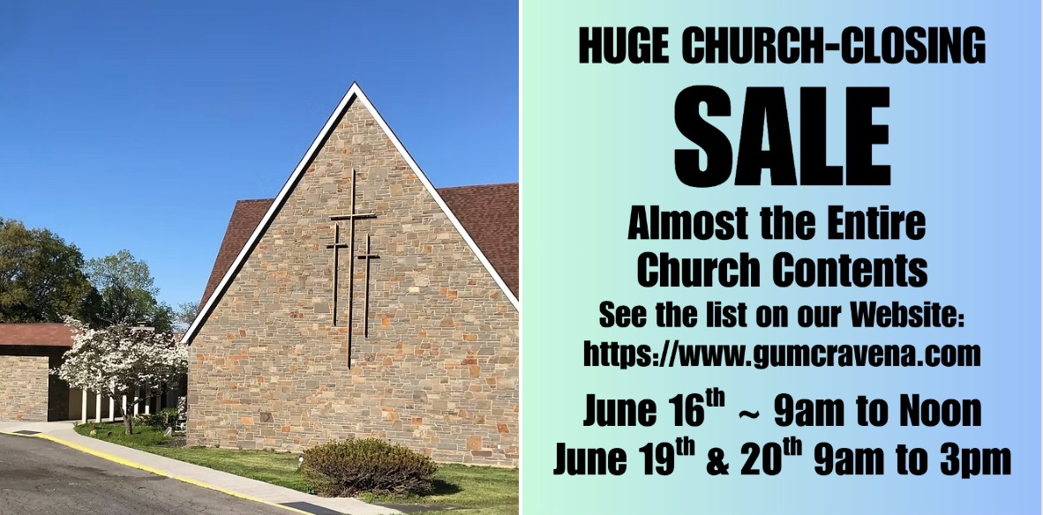
BARGAIN SHED NEWS
PLEASE REMEMBER: We are only accepting summer clothes as the Bargain Shed will be closing on June 27. We want to thank all of our friends for their kindness and support during this difficult time. THANK YOU!!!!

THE ULTIMATE DESTINATION
Few things are better than the first day of a long-awaited vacation. The excitement of reaching our destination, the anticipation of fun-filled adventures, the freedom to relax and lay down our burdens for a while — we’ll pay good money for that.
But it’s a fleeting pleasure. Before our bags are even unpacked, the clock has already begun counting down to when we’ll have to return to the pressures of everyday life.
It won’t always be so. One day, we’ll lay down our burdens for good. When we reach our ultimate destination, God our Father will welcome us. Our loved ones, long gone, will gather to celebrate. And every day of this breathtaking adventure will be like the first because time will no longer rule over us.
The best vacations are just a shadow of what God has in store for his children.


THE QUIET POWER OF FAITHFULNESS
The greatest forces in the universe are rarely spectacular. Gentle summer showers often do more lasting good than hurricanes, though they draw little attention. The world depends on the faithfulness, loyalty and dedication of countless people whose names are never known.

Every life, no matter how humble, has a role in shaping a better world and a more beautiful tomorrow. It is easy to overvalue what seems impressive and underestimate what appears ordinary. Yet lasting change is most often built through quiet commitment, patient service and faithful hearts doing what matters most, day after day.

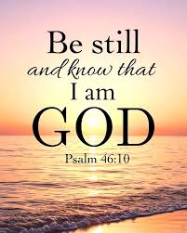
The Father has a plan. Though it’s hard to see it now. You feel you’re walking all alone. But He is there no doubt. When the storm around you rages, and you’re tossed to and fro. When you’re faced with life’s decisions, not sure which way to go.

Stand still and let God move, standing still is hard to do when you feel you have reached the end. He’ll make a way for you. Stand still and let God move.

When the enemy surrounds you, and the walls are closing in, when the tide is swiftly rising, and you wonder where He’s been.
Friend, there never was a moment, that His arms weren’t reaching out. You can rest assured and be secure, God is moving right now.

When you feel you have reached the end, He’ll make a way for you. Stand still and let God move. The answer will come, but only in His time. Stand still and let God move, stand still and let God move. –Anonymouns


THE SACRED PACE OF REST
Jesus, who often withdrew with his disciples to quiet, deserted places, understood something we easily forget: transformation takes time. The richest, most life-giving compost does not form overnight. As author James Gleick observes, “You can’t hurry compost for the same reason you can’t hurry love and you can’t hurry a soufflé. The biochemistry has its own inherent pace.” In much the same way, the most meaningful parts of life unfold slowly. Relationships deepen over years. Wisdom grows through experience. True rest cannot be rushed.
Disciples of Jesus today are invited to rediscover the value of the deserted place. It is not empty or wasted space, but sacred ground. It is where long books can be read, unhurried prayers can be offered and deep thoughts can take root. It is where Sabbath is honored through rest, renewal and quiet attentiveness to God.
In a culture that prizes speed and productivity, stepping away may feel counterintuitive. Yet it is in these still moments that our souls are restored and made fertile for growth. The deserted place becomes a gift, shaping us into people who are grounded, attentive and spiritually mature, ready to reenter the world with renewed strength and purpose.
GRACE UNITED METHODIST CHURCH
16 Hillcrest Drive
Ravena, NY 12143-1409

JOIN US ON FACEBOOK
If you are on Facebook, please join the Church page by liking us at Grace United Methodist Church, Ravena, NY. Find out what’s happening each week, including meetings and special events.
or vISIT US ON THE WEB: www.gumcravena.com

